|  |
| --- |
|  |
| <<Video Rental Store>> |
| Software Requirements Specification |
|  |
| **<<Anish Kumar, Girish Bhatt, Manish Kumar, Vikash Kumar>>**  **<<Brillio>>** |
| **6/10/2015** |

|  |
| --- |
| This document details requirements for <<product>> owned by <<Customer name>>. |

**Document Revision History**

|  |  |  |  |  |  |
| --- | --- | --- | --- | --- | --- |
| **Version No.** | **Date** | **Author** | **Reviewed By** | **Status** | **Comment** |
|  |  |  |  |  |  |
|  |  |  |  |  |  |
|  |  |  |  |  |  |

**Acronyms and Abbreviations**

|  |  |
| --- | --- |
| **Abbreviation** | **Description** |
|  |  |
|  |  |
|  |  |

1 Introduction 4

1.1 Purpose 4

1.2 Organization of the Document 4

1.3 Intended Audience 5

1.4 Product Scope 5

1.5 References 5

2 Overall Description 5

2.1 Product Perspective 5

2.2 Product Functions 5

2.3 User Classes and Characteristics 6

2.4 Operating Environment 6

2.5 Design and Implementation Constraints 6

2.6 User Documentation 6

2.7 Assumptions and Dependencies 6

3 External Interface Requirements 7

3.1 User Interfaces 7

3.2 Hardware Interfaces 11

3.3 Software Interfaces 11

3.4 Communications Interfaces 11

4 System Features 12

4.1 System Feature 1 12

4.1.1 Description and Priority 12

4.1.2 Stimulus/Response Sequences 12

4.1.3 Functional Requirements 12

4.2 System Feature 2 12

4.2.1 Description and Priority 12

4.2.2 Stimulus/Response Sequences 12

4.2.3 Functional Requirements 12

4.3 System Feature 3 13

4.3.1 Description and Priority 13

4.3.2 Stimulus/Response Sequences 13

4.3.3 Functional Requirements 13

4.4 System Feature 4 13

4.4.1 Description and Priority 13

4.4.2 Stimulus/Response Sequences 13

4.4.3 Functional Requirements 13

4.5 System Feature 5 13

4.5.1 Description and Priority 13

4.5.2 Stimulus/Response Sequences 13

4.5.3 Functional Requirements 13

4.6 System Feature 6 14

4.6.1 Description and Priority 14

4.6.2 Stimulus/Response Sequences 14

4.6.3 Functional Requirements 14

5 Other Non-functional Requirements 15

5.1 Performance Requirements 15

5.2 Safety Requirements 15

5.3 Security Requirements 15

5.4 Software Quality Attributes 15

5.5 Business Rules 15

6 Other Requirements 15

7 Appendix A: Glossary 15

8 Appendix B: Analysis Models 16

9 Appendix C: To Be Determined List 16

# Introduction

## Purpose

The purpose of the Software Requirements Specification document is to clearly define the system under development, namely the Video Rental System (VRS). This system provides services to the owner, clerk and users to access the information about the videos. The owner and clerks can keep track of the inventory of store as well as user information. Whereas users can search, browse and book a copy of video. This system provides digital way to do the business instead of the old manually operated business.

## Organization of the Document

*<<Describe any standards or typographical conventions that were followed when writing this SRS, such as fonts or highlighting that have special significance. For example, state whether priorities for higher-level requirements are assumed to be inherited by detailed requirements, or whether every requirement statement is to have its own priority. >>*

## Intended Audience

The intended audience of this document includes the owner of the video store, the clerks of the video store, and the end users of the VRS. Other intended audience includes the development team such as the requirements team, requirements analyst, design team, and other members of the developing organization.

## Product Scope

The owner of a local video store wanted to create a new business plan where everything about renting a video (except the picking up and returning of videos) was done online. Therefore, the new VRS will allow the following functionality online: to search for videos, to become members, to rent videos, to modify membership information, and to pay overdue fees. The store personnel may use the VRS to process the rented or returned videos, to add or remove videos to/from his store’s video inventory and to update video information. The VRS is intended to increase the owner’s profit margin by increasing video sales with this unique business approach and by allowing him to reduce the staffing needed in his stores.

## References

*<<List any other documents or Web addresses to which this SRS refers. These may include user interface style guides, contracts, standards, system requirements specifications, use case documents, or a vision and scope document. Provide enough information so that the reader could access a copy of each reference, including title, author, version number, date, and source or location. >>*

# Overall Description

## Product Perspective

Video Rental is a project which helps the video rental shop owner to keep a record of all the types of videos/movies/game CDs and also provides an option to the customer to register and avail the services and discount available.

## Product Functions

Major functionalities of this project are:

* Keep record of all the CDs available.
* Provide customer registration.
* Notification
* Customer history
* CD availability
* Advance booking for CD and alteration

## User Classes and Characteristics

This project is for the shopkeeper, which enables him/her to keep record of all the CD items present in store as well as in return provides the customers with an option to register him/her self which will help him/her to plan which movie he/she can watch prior visiting to the shop.

## Operating Environment

This project is a standalone application that should operate on the Windows operating systems with WinXP or WndowsVista or Windows8. This application can be implemented as a console based application or web browser based application or windows based application.

## Design and Implementation Constraints

1. Customer must have internet connection in order to access the web page.
2. Scenario like: If the last copy of a particular type is issued by a costumer ‘A’ has planned to return it at 5pm and another customer B calls in for booking for the same CD at 4:30pm and he has booked it from 5:10pm, unfortunately customer A has not returned it till that time.

## User Documentation

‘Help’ option is available online which will guide the customers to navigate on the web page. A hardcopy of ‘help manual’ will be given only to the shopkeeper.

## Assumptions and Dependencies

Software should work properly when design and Implementation constraints are not met.

# External Interface Requirements

## User Interfaces

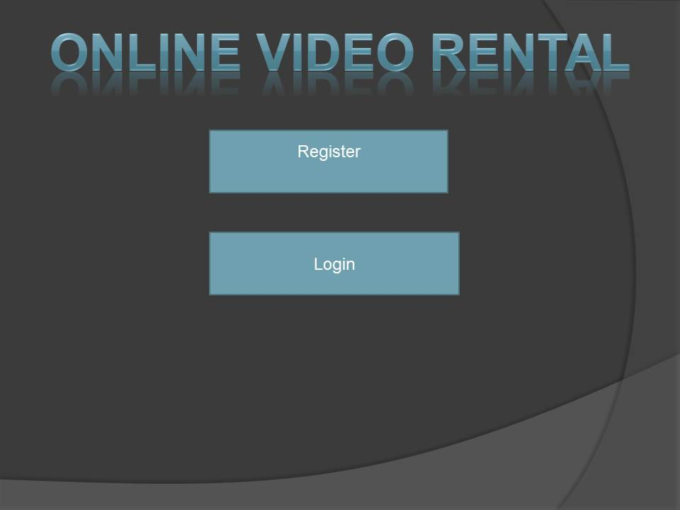

In Online video Rental project there are two types of option .. (1) Register and (2) Login

(1).register-First time User Register to give their Details

(2) Login- This is for authorization, for user who is registered and gives their credentials to access the software

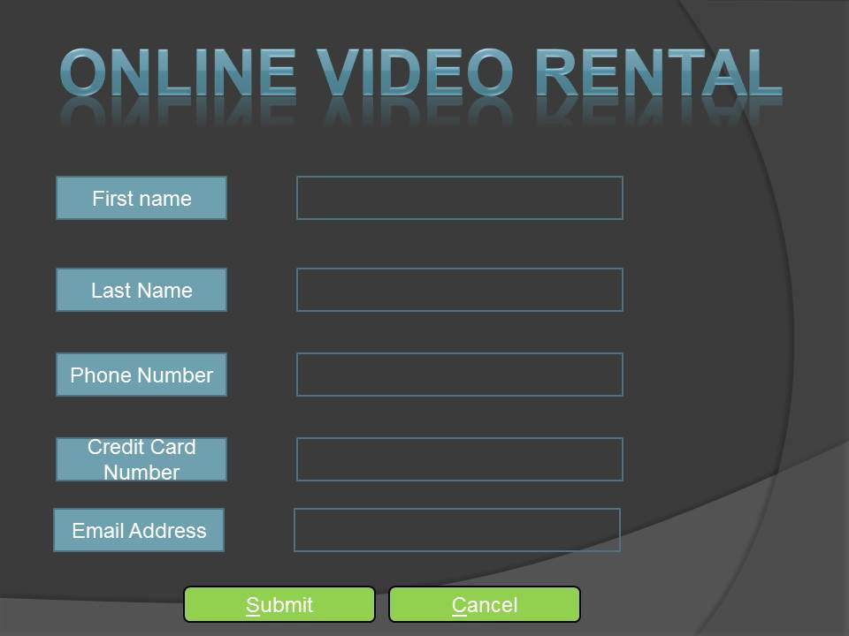

This is Registration form where user gives their details,

First name, last name, and credit card number, phone number

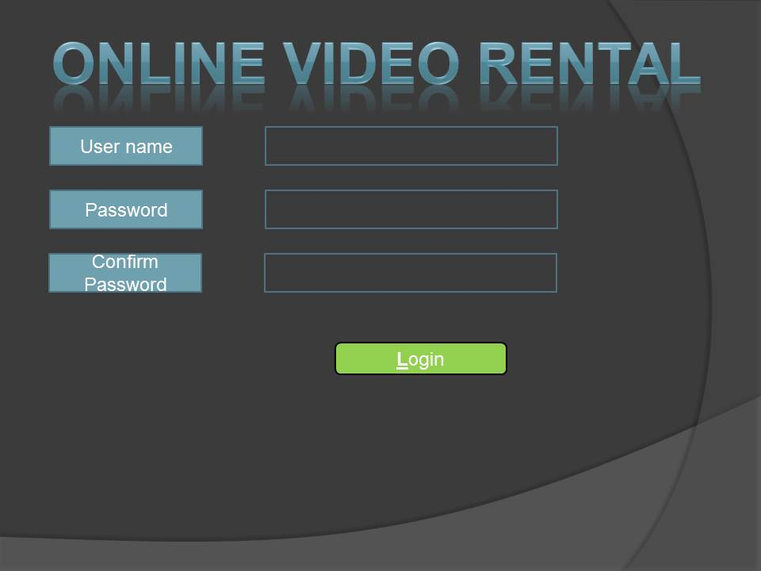

This Page is use for login, where user gives their username and password to access the software.

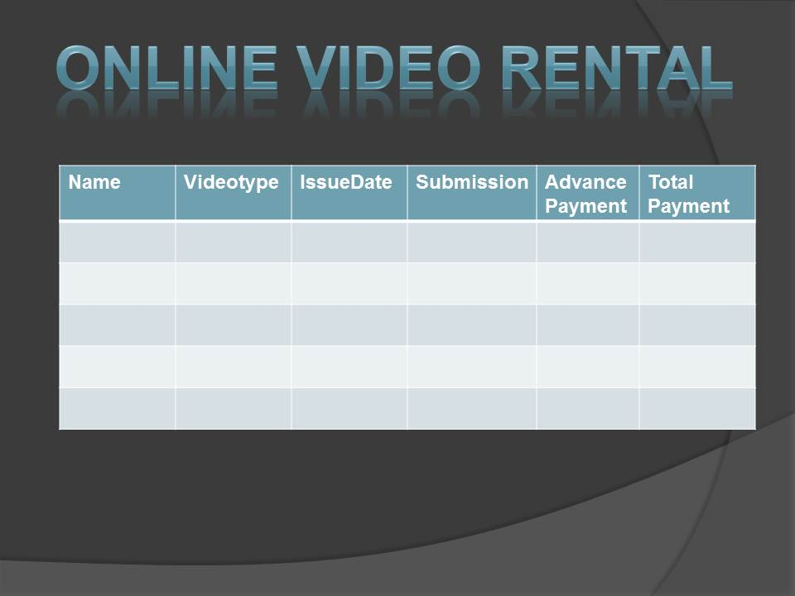

This page displays the Videos details which is available in the shop, and what is the status of Video

For eg.. Rent Price Video type

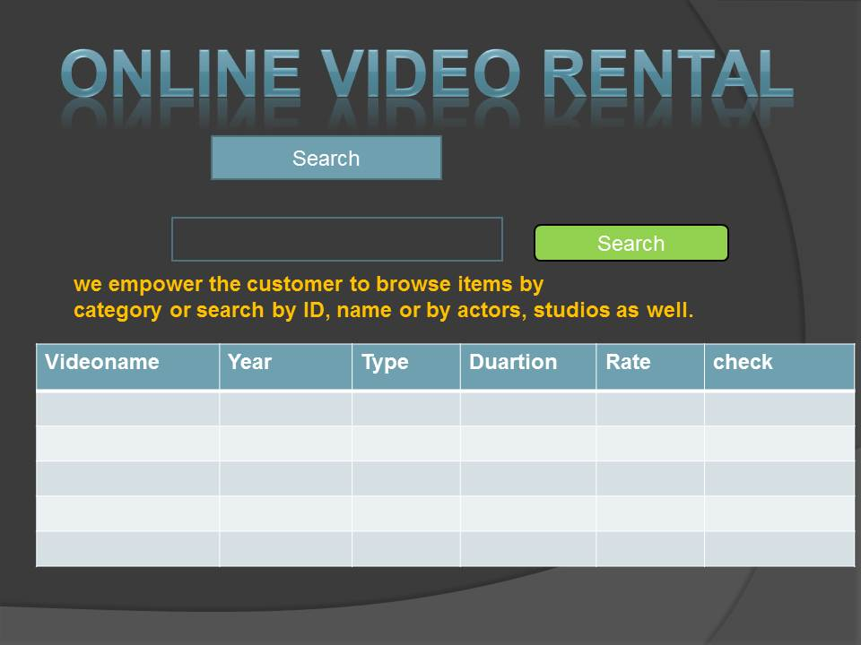

This page is use for search the video with their id, name or by actors, studios as well.

## Hardware Interfaces

* Apache tomcat
* 4 GB Ram
* 100 GB
* 64-bit Operating System
* Intel (R) I3-3220 CPU @ 3.30GHz

## Software Interfaces

* Windows 7
* Eclipse IDE
* My Sql
* Chrome Browser
* Notepad++

## Communications Interfaces

Browsers

Chrome

Mozilla

Safari

Internet Explorer

Protocol

HTTP

# System Features

*<This template illustrates organizing the functional requirements for the product by system features, the major services provided by the product. You may prefer to organize this section by use case, mode of operation, user class, object class, functional hierarchy, or combinations of these, whatever makes the most logical sense for your product.>*

## System Feature 1

User registration

### Description and Priority

The software system provides the facility to register users to enable them to avail various functionalities and benefits. This is very high priority functionality.

### Stimulus/Response Sequences

The list of actions of the user includes the inputting of all the necessary details required for the registration process. The system may respond with a message depending on the success of registration.

### Functional Requirements

REQ-1: The essential functional requirement for this feature would include form level validation and also displaying appropriate messages depending on the success and failure of the registration process.

## System Feature 2

Logging in of previously registered users.

### Description and Priority

The software system provides the facility to login the already registered users and enable them to avail the various facilities of the system. This is high priority functionality.

### Stimulus/Response Sequences

The list of actions of the user includes the inputting of login credentials. The software system may in turn respond with an appropriate message depending on the success or the failure of the logging in process.

### Functional Requirements

REQ-2: The credentials entered by the user must be checked against the details stored in the database. And an appropriate message should be displayed depending on the success or the failure of finding the match of the inputted credentials.

## System Feature 3

Search

### Description and Priority

The software system provides the facility to search for various kinds of information pertaining to the availability of a particular video as per the customer’s desire. This is medium priority functionality.

### Stimulus/Response Sequences

The list of actions of the user includes the inputting the name of the video to be searched .The software system may in turn respond with an appropriate message depending on the success or the failure of locating the desired video.

### Functional Requirements

REQ-3: The video name entered by the user must be checked against the details of videos stored in the database. And an appropriate message should be displayed depending on the success or the failure of finding the match of the inputted video name.

## System Feature 4

Browse

### Description and Priority

The software provides the facility to browse through various videos based on genres, high rated videos, most-popular videos and upcoming videos. This is high priority functionality.

### Stimulus/Response Sequences

The list of actions of the user includes the selection of different kind of details of the video based on genres, highly rated, most popular and upcoming videos views .if a particular view is not available, the user is prompted with appropriate messages.

### Functional Requirements

## System Feature 5

Feedback

### Description and Priority

The software provides the facility to provide valuable feedback based on their experience of watching a particular video. This feedback may prove to be of high weightage for other users to rent that video. This is low priority functionality

### Stimulus/Response Sequences

The list of actions of users includes providing their feedback based on their experience. This feedback is supposed to be written in the area provided. The submitted feedback must be reflected back on to the general view of the software system making it visible for other potential users to go through the feedback.

### Functional Requirements

REQ-4: Every user must be provided with facility to provide feedback based on the experience of the services availed. And also every user must be able to read the feedback provided by others.

## System Feature 6

Shopkeeper’s view

### Description and Priority

The software provides full access to the shopkeeper regarding each aspect of the software system. The shopkeeper can read and write details of the customers where the details include: the details ofthe customer and his previous issues, customer name, contact number, date of issue, expected return date, expected rent, duration of use of the video, number of copies of a particular video,etc…….. This is high priority functionality

### Stimulus/Response Sequences

The list of actions of the shopkeeper includes the populating the database with details of the customer and also the necessary details of the video rented i.e. to write the details into database. And also to fetch the details from the database ((i.e.) read).if the queried details are not available in the database the system responds with appropriate message.

### Functional Requirements

The core functionalities of the shopkeeper includes: reading or fetching of records, writing the records, updating the records and deleting the records.

# Other Non-functional Requirements

## Performance Requirements

The response time of the system should remain fairly constant with increase in the data. The system shall provide persistent storage for membership, rental, and video inventory information.

## Safety Requirements

Every user of the system will have a username and password to access the system. No unauthorised user is allowed to use the system except browse for the video. The case of any damage or disaster a backup database should be there to protect the data from any loss.

## Security Requirements

The system shall provide a secure environment for financial transactions and for the storage of confidential member information.

## Software Quality Attributes

*<Specify any additional quality characteristics for the product that will be important to either the customers or the developers. Some to consider are: adaptability, availability, correctness, flexibility, interoperability, maintainability, portability, reliability, reusability, robustness, testability, and usability. Write these to be specific, quantitative, and verifiable when possible. At the least, clarify the relative preferences for various attributes, such as ease of use over ease of learning.>*

## Business Rules

*<List any operating principles about the product, such as which individuals or roles can perform which functions under specific circumstances. These are not functional requirements in themselves, but they may imply certain functional requirements to enforce the rules.>*

# Other Requirements

*<Define any other requirements not covered elsewhere in the SRS. This might include database requirements, internationalization requirements, legal requirements, reuse objectives for the project, and so on. Add any new sections that are pertinent to the project.>*

# Appendix A: Glossary

*<Define all the terms necessary to properly interpret the SRS, including acronyms and abbreviations. You may wish to build a separate glossary that spans multiple projects or the entire organization, and just include terms specific to a single project in each SRS.>*

# Appendix B: Analysis Models

*<Optionally, include any pertinent analysis models, such as data flow diagrams, class diagrams, state-transition diagrams, or entity-relationship diagrams.>*

# Appendix C: To Be Determined List

*<Collect a numbered list of the TBD (to be determined) references that remain in the SRS so they can be tracked to closure.>*